**Week 2 Portfolio**

For this week’s lecture and practical classes , I learned of the Android side of the Xamarin platform such as the Android activity lifecycle, how to create a listview activity to display information etc. The classes so far have been beneficial to my knowledge and it provided me with a better introductory glimpse at Xamarin coding standards. As for the first assessment for SIT313, I have also put a lot of thought and planning into my first Xamarin assignment.

In my proposed work, I aim at developing an iOS application using Xamarin framework that helps improve productivity of its user by helping them concentrate on the task at hand. Since it is impossible for any individual to remain focus on a single task for a longer period of time. I aim at providing our user just enough time till he loses his focus, after that period a small break is suggested. This should improve the productivity, but since being too strict for anything isn’t good. Our application has a feature of extending the time slot just by a little. Apart from that there will be a user login activity, as well as user’s Pomodoro tracker that keeps a log of all the Pomodoro that user created from the time of the installation of the application. This application will also visualize these data in form of graphs. Though it is not favoured but still having such an option would not break the consistency of the task and taking a break of say 5 minutes just to complete the task in the next minute sounds absurd, hence the user may extend the job just for a little while for such special cases.

**Project Features:** The application has the following features –

1. User Login/Signup – Any user can sign up to create a personalized account where all his activities related to the Pomodoro creation is stored.
2. View Previous history – This application has a visualization activity that uses graphs to show all the Pomodoro created from the time of installation of app, It also shows other valuable information such as how many times the user lost focus or extended the Pomodoro.
3. Activity Tracker – This application can check for how long the user was using his/her iphone and for how long during a Pomodoro the iphone was used i.e. the iphone acted as a negative agent and actually decreased the productivity.
4. Configuration – User is able to decide the time period of the task and break
5. Start Pomodoro – Just by a button click a notification is scheduled that is activated after the desired time period reminding the user to pause the task at hand and go for a break.
6. Extend Task – Every notification has a extend option, For any task it might not be possible to just pause it at any moment of time and go for a break, in some special situations this might not be beneficial hence we have added this feature to extend the task
7. Extend Break – Similarly while you are on a break it might not be possible for you to just leave whatever you were doing and just focus on the work. In such a case, you extend the break and continue the work only when you are ready to do it with all your will.
8. Notification – Custom notification is made to greet the user on every event. The notification contains some useful message and an image to help motivate the user to go for the desired task.
9. Countdown Timer – There will be a countdown timer that will indicate how much time is left for the alarm to ring.
10. Custom sound – A classical alarm sound is used to bring the attention of its user to the application for every important event.

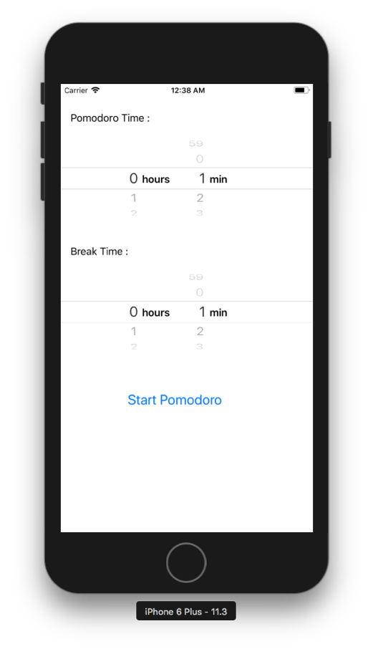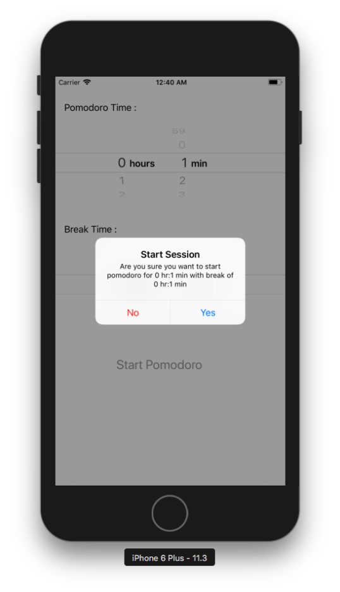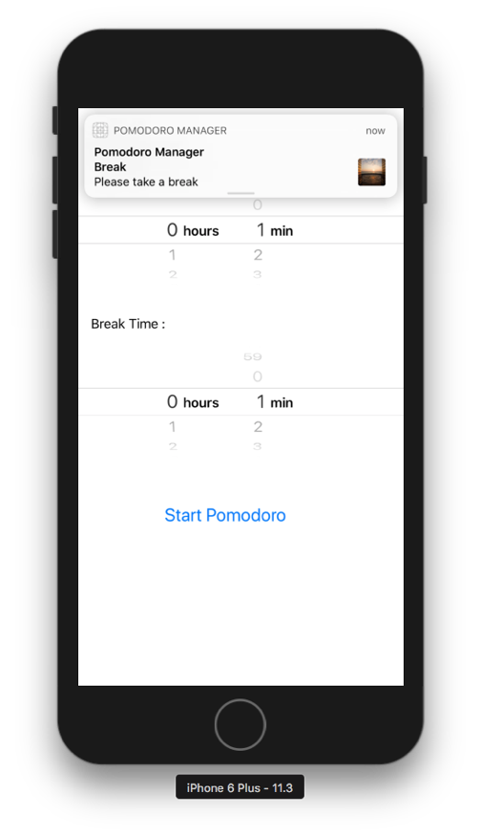

**Flow Charts :**

